Why Use .NET framekwork to build this application?

the best framework to develop a desktop application? Undoubtedly, it is .NET. Why? DOT NET consists of a number of tools, library, and compiler components. These tools along with the .NET specific programming language can be used for desktop application development that runs on Windows.

* Both .Net and .NET Core has robust class libraries.
* .Net Core improves the performance and scalability of apps without any extra effort.
* .Net framework can be installed as a single package while .NET Core can be packaged independent of the OS.
* .NET Core supports emerging technologies like cloud, IoT, and machine learning in Visual Studio while .NET framework needs to use ASP.NET for cloud capabilities.

CODE SCREEN SHOTS

IDIOMS BEFORE ADDING NEW DATA TO IT

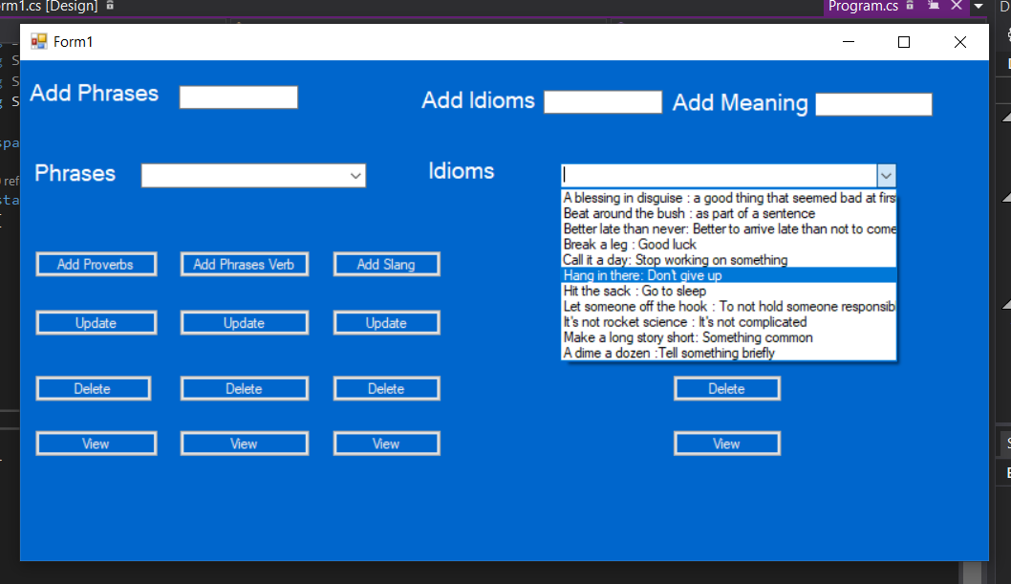

**IDIOMS AFTER ADDING NEW DATA TO IT**

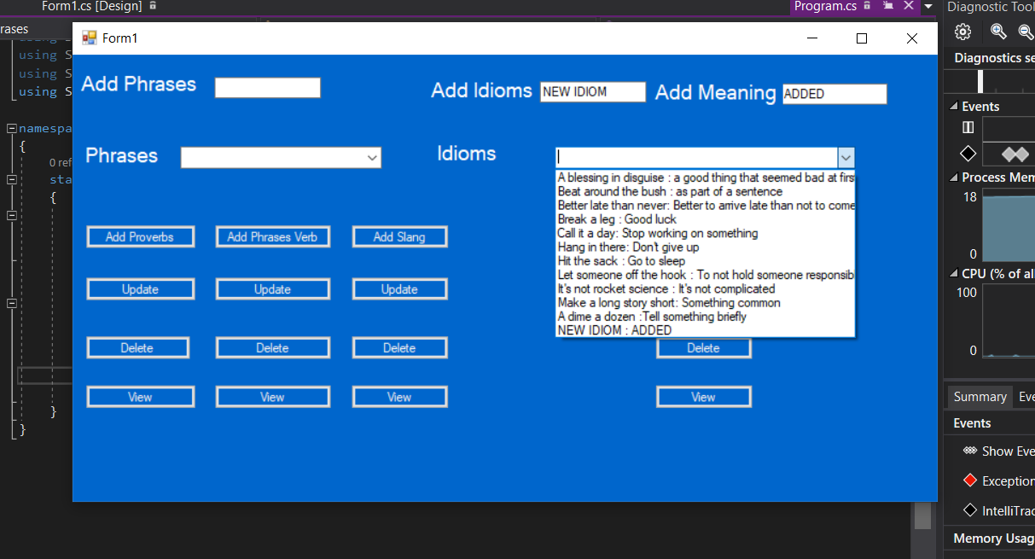

**SOME IDIOMS DELETED FROM THE START**

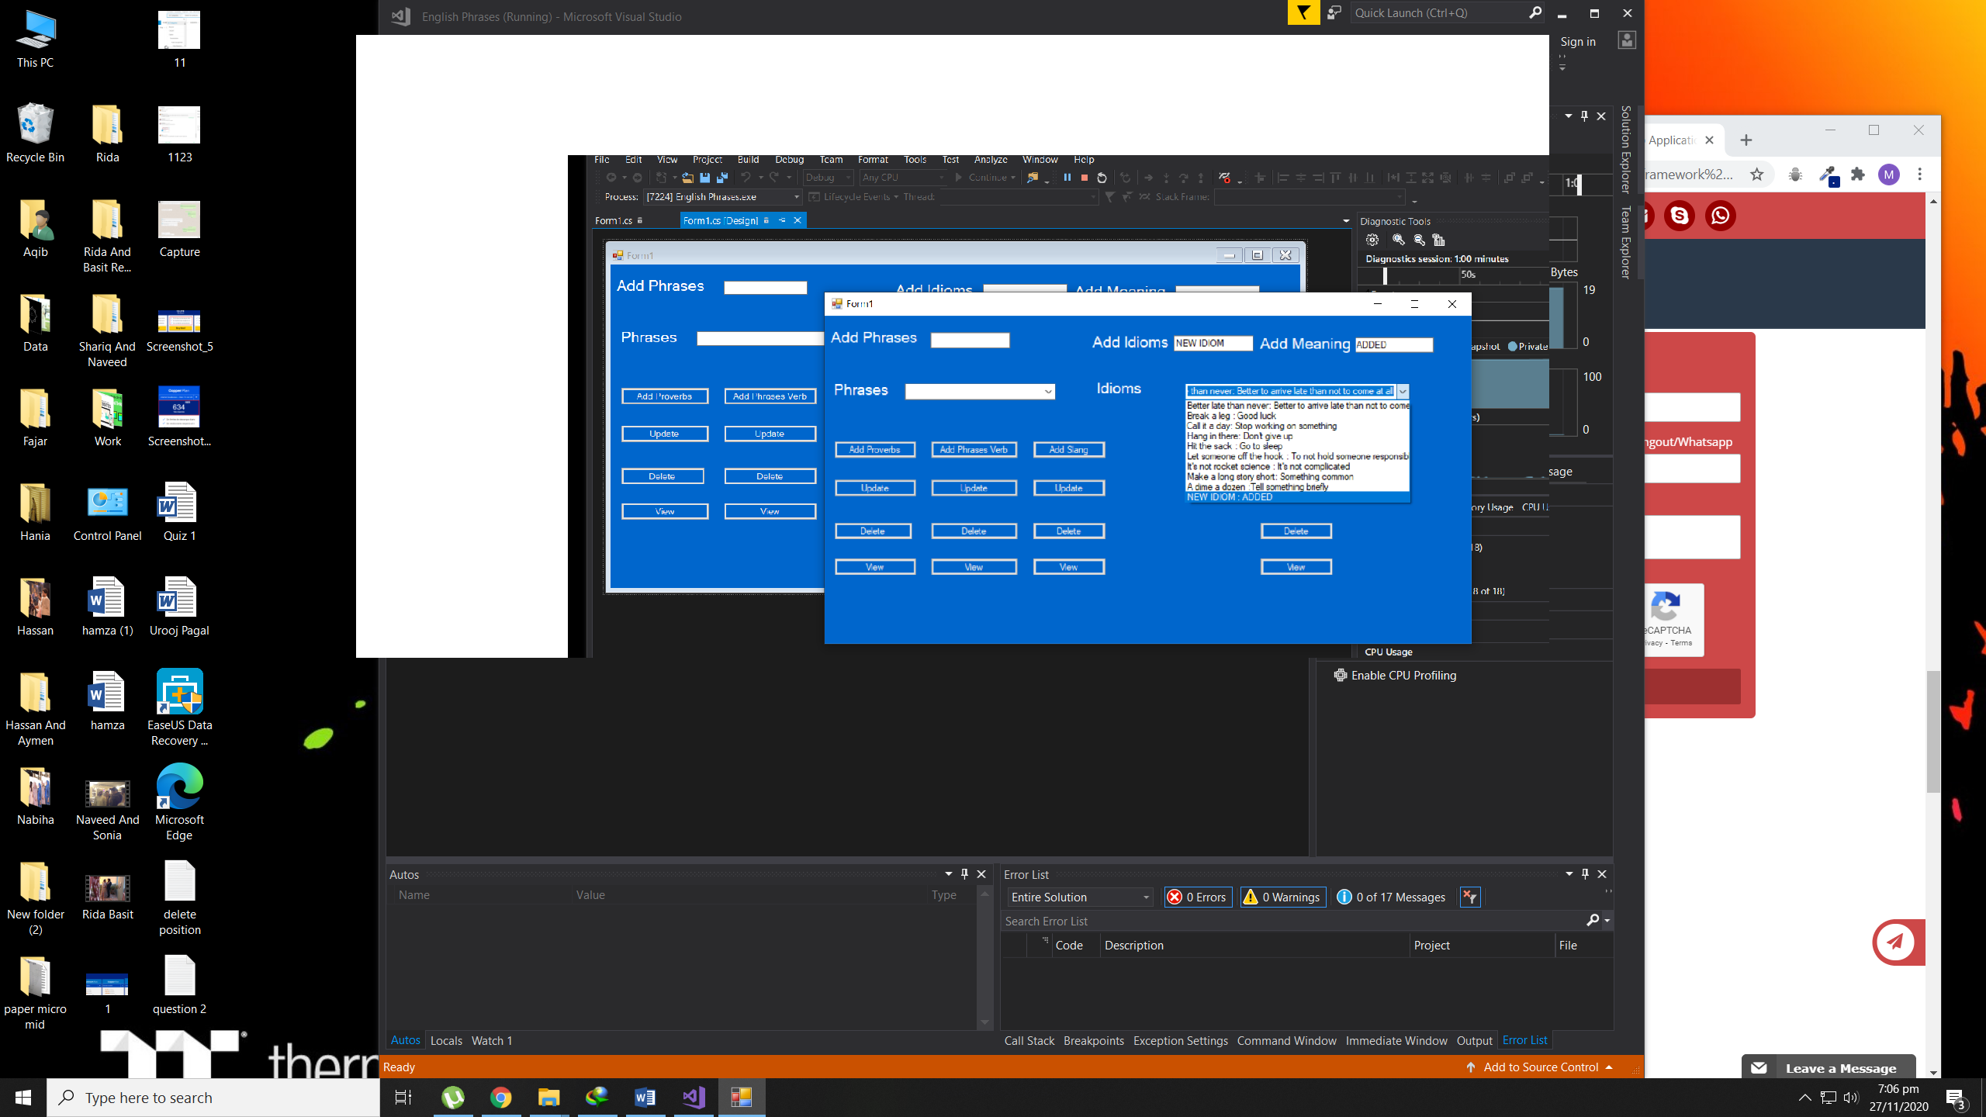

CODE :

using System;

using System.Collections.Generic;

using System.ComponentModel;

using System.Data;

using System.Drawing;

using System.Linq;

using System.Text;

using System.Threading.Tasks;

using System.Windows.Forms;

namespace English_Phrases

{

public partial class Form1 : Form

{

List<string> Provers = new List<string>() { "Absence makes the heart grow fonder", "Actions speak louder than words.", "A journey of a thousand miles begins with a single step", "All good things must come to an end", "If it ain’t broke, don’t fix it", "If you play with fire, you’ll get burned", "A picture is worth a thousand words", "A watched pot never boils", "Beggars can’t be choosers", " Better late than never", " Don’t bite the hand that feeds you", "Easy come, easy go", "No man is an island", "The early bird gets the worm" };

List<string> Phrases_Verb = new List<string>() {"do","go","Rest","Ride","Beat","Become","Begin","Bend","Sleep","Work","Need","Study","Practice","Learn","Make","Call","Arise","Burn","Forget" };

List<string> Slng = new List<string> {"chill","cool","Busted","Ride","Hip", "Frenemy", "BAE", "Basic", "Coin", "Dying", "Epic", "Fierce" };

List<string> idoms = new List<string> { "A blessing in disguise : a good thing that seemed bad at first ", "Beat around the bush : as part of a sentence", "Better late than never: Better to arrive late than not to come at all", "Break a leg : Good luck", "Call it a day: Stop working on something", "Hang in there: Don't give up", "Hit the sack : Go to sleep", "Let someone off the hook : To not hold someone responsible for something", "It's not rocket science : It's not complicated", "Make a long story short: Something common", "A dime a dozen :Tell something briefly"};

public Form1()

{

InitializeComponent();

}

private void button1_Click(object sender, EventArgs e)

{

Provers.Add(textBox1.Text);

Refresh("Data Added!", Provers, comboBox1);

}

private void button2_Click(object sender, EventArgs e)

{

Phrases_Verb.Add(textBox1.Text);

Refresh("Data Added!",Phrases_Verb, comboBox1);

}

private void button3_Click(object sender, EventArgs e)

{

Slng.Add(textBox1.Text);

Refresh("Data Added!", Slng, comboBox1);

}

private void button6_Click(object sender, EventArgs e)

{

Provers.Remove(comboBox1.SelectedItem.ToString());

Refresh("Data Deleted!", Provers, comboBox1);

}

private void button4_Click(object sender, EventArgs e)

{

string msg = "View Added!";

Refresh(msg, Provers, comboBox1);

}

private void button7_Click(object sender, EventArgs e)

{

Phrases_Verb.Remove(comboBox1.SelectedItem.ToString());

Refresh("Data Deleted!", Phrases_Verb, comboBox1);

}

private void button9_Click(object sender, EventArgs e)

{

Refresh("View Added!", Phrases_Verb, comboBox1);

}

private void button12_Click(object sender, EventArgs e)

{

Refresh("View Added!", Slng, comboBox1);

}

private void button10_Click(object sender, EventArgs e)

{

Slng.Remove(comboBox1.SelectedItem.ToString());

Refresh("Data Deleted!", Slng, comboBox1);

}

private void button13_Click(object sender, EventArgs e)

{

string id = "GOOD";

string me = "Good is use for more people";

comboBox2.Items.Add(id+" : "+me);

}

public void Refresh(string msg , List<string> proverb, ComboBox combo)

{

combo.Items.Clear();

foreach (var item in proverb)

{

combo.Items.Add(item);

}

MessageBox.Show(msg);

}

private void button5_Click(object sender, EventArgs e)

{

try

{

if (textBox1.Text == "")

{

MessageBox.Show("Please Select");

}

else

{

Provers.Remove(comboBox1.SelectedItem.ToString());

Provers.Add(textBox1.Text);

Refresh("View Updated", Provers, comboBox1);

}

}

catch { MessageBox.Show("Something wrong"); }

//textBox1.Text = comboBox1.SelectedItem.ToString();

// select[1] = "sdf";

}

private void button8_Click(object sender, EventArgs e)

{

try

{

if (textBox1.Text == "")

{

MessageBox.Show("Please Select");

}

else

{

Phrases_Verb.Remove(comboBox1.SelectedItem.ToString());

Phrases_Verb.Add(textBox1.Text);

Refresh("View Updated", Phrases_Verb, comboBox1);

}

}

catch { MessageBox.Show("Something wrong"); }

}

private void button11_Click(object sender, EventArgs e)

{

try

{

if (textBox1.Text == "")

{

MessageBox.Show("Please Select");

}

else

{

Slng.Remove(comboBox1.SelectedItem.ToString());

Slng.Add(textBox1.Text);

Refresh("View Updated", Slng, comboBox1);

}

}

catch { MessageBox.Show("Something wrong"); }

}

private void button16_Click(object sender, EventArgs e)

{

string t1 = textBox2.Text+ " : "+textBox3.Text;

idoms.Add(t1);

Refresh("Value Added", idoms, comboBox2);

}

private void button14_Click(object sender, EventArgs e)

{

string t1 = textBox2.Text + " : " + textBox3.Text;

try

{

if (textBox2.Text == "" || textBox3.Text=="")

{

MessageBox.Show("Please Select");

}

else

{

Slng.Remove(comboBox2.SelectedItem.ToString());

Slng.Add(t1);

Refresh("View Updated", Slng, comboBox2);

}

}

catch { MessageBox.Show("Something wrong"); }

}

private void button13_Click_1(object sender, EventArgs e)

{

idoms.Remove(comboBox2.SelectedItem.ToString());

Refresh("Data Deleted!", idoms, comboBox2);

}

private void button15_Click(object sender, EventArgs e)

{

Refresh("View Added", idoms,comboBox2);

}

}

}